CLADOGRAM PRACTICE Name: Per:

1. 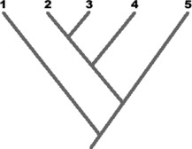Based on the cladogram shown, we can conclude that species 2 is most closely related to species

A. 1 B. 3 C. 4 D. 5 E. 1 or 3

1. The cladogram shows the evolution of land plants as indicated by fossil records.

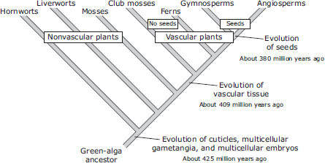Which discovery would challenge the validity of this cladogram?

**A** A large aquatic vascular plant about 200 million years old

**B** A species of algae that has existed for less than one million years

**C** A moss species that has existed for less than 380 million years

**D** A fossil of a fern more than 425 million years old

1. Use the following characteristics of these organisms to make a cladogram. Remember that all organisms started with a common ancestor, so all cladograms should start from a single point and branch as they develop differing characteristics.

|  |  |  |  |  |
| --- | --- | --- | --- | --- |
| Characteristics | Shark | Bullfrog | Kangaroo | Human |
| Vertebrae | X | X | X | X |
| Two pairs of  limbs |  | X | X | X |
| Mammary  Glands |  |  | X | X |
| Placenta |  |  |  | X |

1. 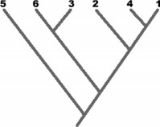Consider the cladogram associated with the question. Which pair of species shares the greatest number of derived characters?
   1. 1 and 4 D. 5 and 6
   2. 6 and 3 E. 5 and 1
   3. 6 and 1
2. 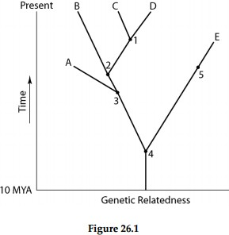A common ancestor for both species C and E could be at position number

A) 1 B) 2 C) 3 D) 4 E) 5

1. Use the following data table to construct a cladogram of the major plant groups below. The table shows which plants have the traits listed.

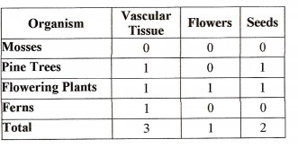

1. Create a branching cladogram from the evidence below

